Experiment:10 Date:28/07/2026

To Implement the A* (A-Star) Search Algorithm

Aim:
To develop a Python program to implement the A* Search Algorithm for finding the shortest path from a source node to a goal node using heuristic values.

Algorithm (A* Search)
- Read the graph and heuristic values.
- Read the start node and goal node.
- Initialize the open list with the start node.
- Select the node with the lowest f(n) = g(n) + h(n).
- Expand the selected node and update its neighbors.
- Repeat until the goal node is reached.
- Display the shortest path.

Program:

graph = {}
heuristic = {}
n = int(input("Enter Number of Nodes: "))

for i in range(n):
node = input("\nEnter Node: ")
h = int(input("Enter Heuristic Value: "))
heuristic[node] = h
adj = {}
m = int(input("Enter Number of Adjacent Nodes: "))

for j in range(m):
v = input("Adjacent Node: ")
c = int(input("Cost: "))
adj[v] = c
graph[node] = adj
start = input("\nEnter Start Node: ")
goal = input("Enter Goal Node: ")

path = [start]
cost = 0
current = start

print("\nPath Traversal")

step = 1

while current != goal:
print(f"Step {step} : {current}")
step += 1
next_node = min(graph[current], key=lambda x: graph[current][x] + heuristic[x])
cost += graph[current][next_node]
current = next_node
path.append(current)
print(f"Step {step} : {goal}")
print("\nShortest Path:")
print(" -> ".join(path))
print("Total Cost =", cost)

OUTPUT:
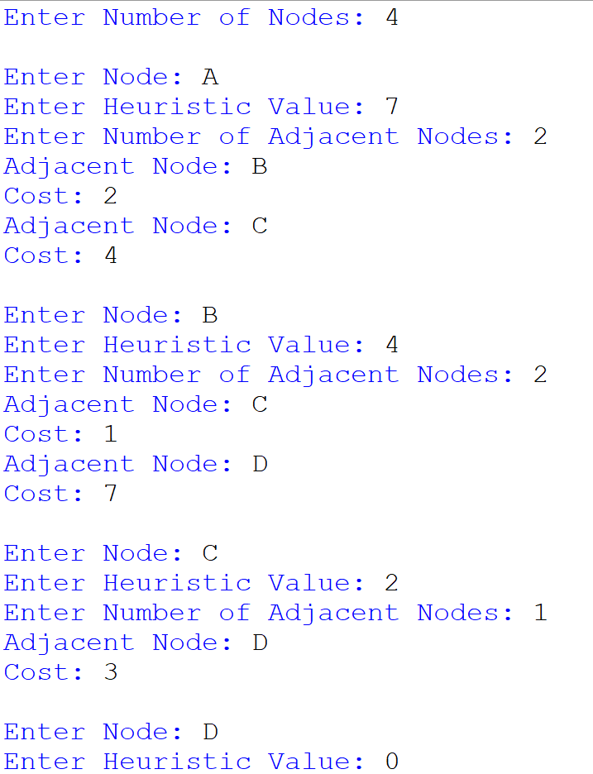

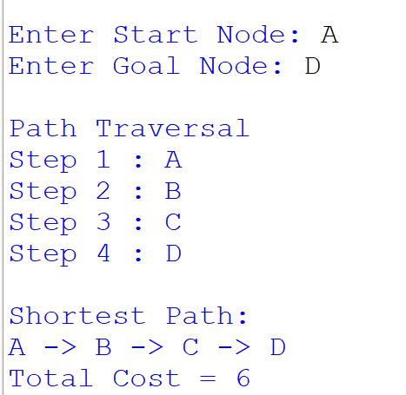

Result:
Thus, the A* Search Algorithm was implemented successfully, and the shortest path from the start node to the goal node was obtained using heuristic values.

